**Stat 401 A: Lab 8 – fitting a simple linear regression**

Goals:

Fit a simple linear regression and estimate the intercept and slope

This example uses a small data set from a hypothetical study of advertising expenditure and sales. The observation unit one month of sales. The advertising expenditure variable is the dollar amount spent on advertising at the beginning of the month. The data are in adsales.txt on the JMP lab page.

Use File / Open / Text import preferences (the default) to read the adsales.txt file. There are two columns: ADVEXP_X (advertising expenditure, the X variable) and SALES_Y (sales, the Y variable). Both should be numbers (blue ramp).

There are two major ways to fit a simple linear regression (one X variable):

the Fit Y by X platform

the Fit model platform

These choices parallel the distinction between these two platforms when the X variable indicates groups.

**Using the Fit Y by X platform:**

Select Analyze / Fit Y by X, put SALES_Y into the Y, response box and ADVEXP_X into the X, factor box. Click OK.

JMP will display a scatterplot of the X and Y variables. There is a lot more available under the red triangle. Left click the red triangle. The popup menu will look like:

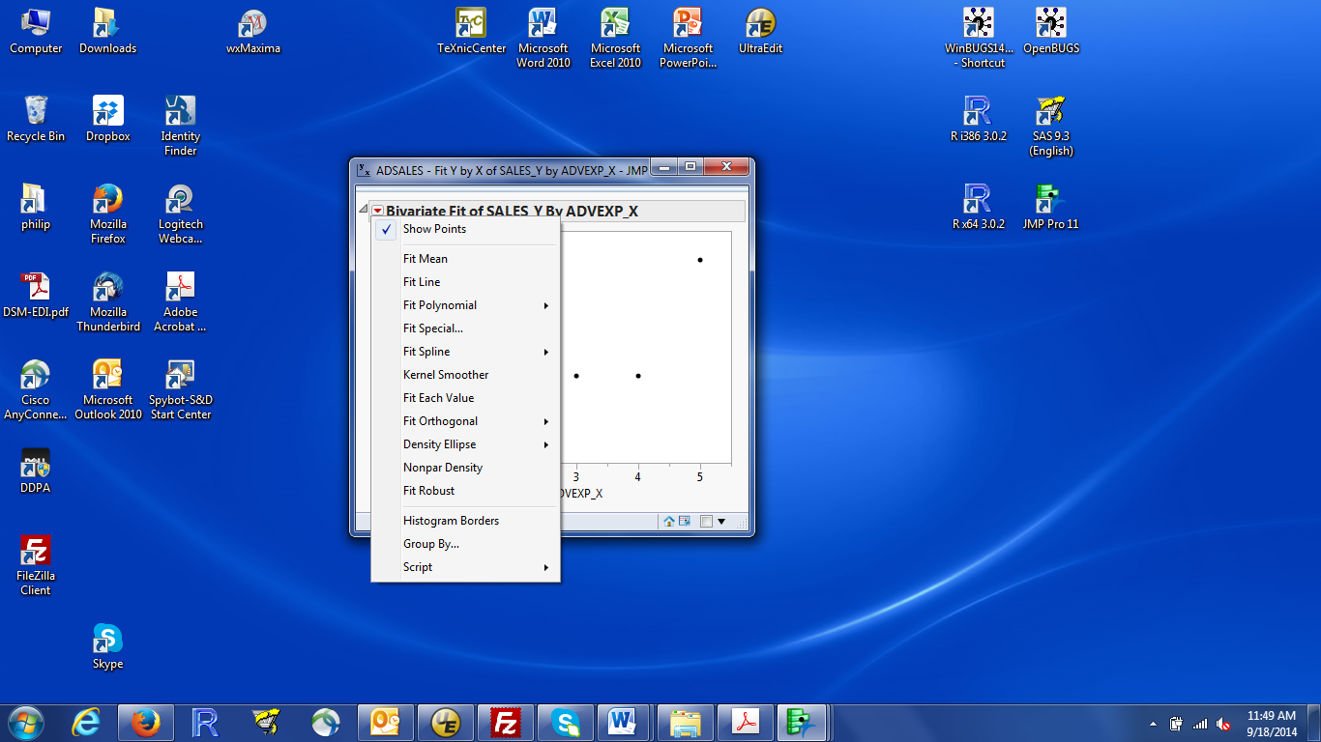

Select Fit Line, which fits a straight line regression model to the data.

JMP will add numeric results below the plot. The results window will now look like:

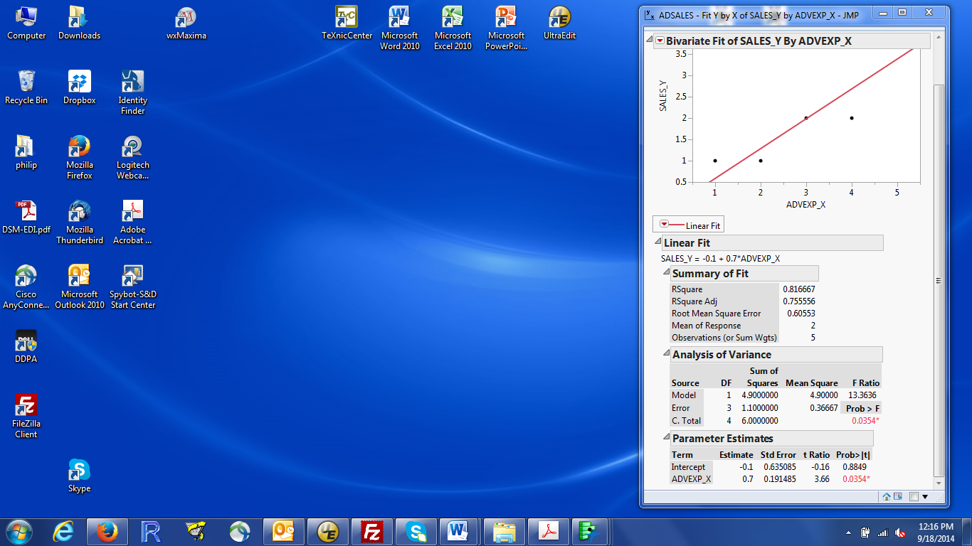

We have not talked about most of these numbers (but we will talk about most of them later). For now, we need the estimated intercept and estimated slope. Those are found in two places in the results:

a. Immediately below Linear Fit, at the top of the numeric results. This is the fitted equation. Make sure you remember which value is the intercept and which is the slope

b. In the parameter estimates box at the bottom of the results. The intercept is labelled as Intercept. The slope is labelled by the name of the corresponding X variable (here, ADVEXP_X). That’s because later we will have models with one intercept and multiple slopes. Labelling by the X variable uniquely identifies each slope. The estimated values are in the estimate column.

**Using the Fit model platform:**

Select Analyze / Fit Model, put SALES_Y into the Y box. Use the Add button to put ADVEXP_X into the model effects box (or drag and drop into that box). I usually change Emphasis to Minimal Report, because I ignore most of the plots added by the default Effect Leverage. Click OK.

As with the Fit Y by X results, we will talk about most of these numbers in the next week or so.

The estimated intercept and slope are found in the Parameter Estimates box. The explanation is the same as the explanation of that box in the Fit Y by X results.